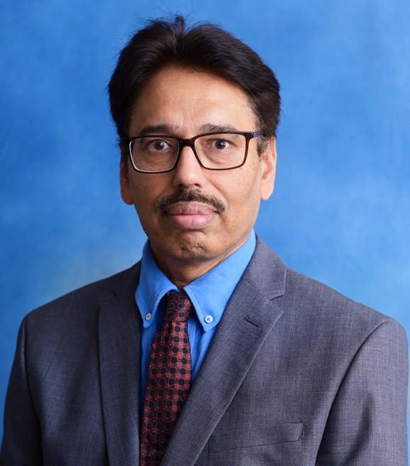

**Mr Khurshid Alam**

MBBS, MRCS- Glasgow, MSc Surgical Sciences, FCPS (Plastic Surgery) FRCEM (Fellow of Royal College Emergency Medicine)

Mr Khurshid Alam, Consultant Kingston NHS Hospital is widely trained in Plastic, Reconstructive surgery and Regenerative Medicine in the UK and Pakistan. Mr K Alam is dedicated to patient education and mutual decision-making, ensuring patients feel informed, supported, and involved with their treatment and aesthetic outcomes.

Mr K Alam achieved his Primary Medical Qualification and completed his initial residency in The Aga Khan university followed by an MSc from The Queen Mary University in London. His Plastic and Reconstructive surgery training was subsequently carried out at The Royal London Hospital, Queen Elizabeth Hospital Birmingham and Queen Victoria Hospital East Grinstead, where he was able to build and refine surgical skills, involved in clinical research and gained invaluable experience working alongside world class surgeons. Mr K Alam’s passion for Regenerative Medicine led him to spend one year conducting postdoctoral research in stem cell biology at the School of Engineering and Material Science (SIMS) laboratory, Queen Mary University London, furthering his experience and insight in the management of of hypertrophic scar and keloid, which assist him to improve his surgical outcomes. Mr. Khurshid is benefited with extensive plastic surgery training in Pakistan which is complemented by further training in multiple plastic surgery centres in NHS and privately working with Mr Riaz in Hull , Mr Vadodaria and Mr Taimur Shoaib in London at aesthetic plastic surgery centres advancing his training in the field of aesthetic surgery.

His exposure in other surgical specialties including neurosurgery at   the Institute of Neurological Sciences (INS) Glasgow allows him to look after his patients with broader clinical knowledge.

Alongside his NHS work as Consultant Emergency Medicine at Kingston Hospital , Mr K Alam currently sees patients at The MACS clinic in Watford relevant his speciality and commonly performs procedures;-

1. 3-D-liposuction
2. Gynecomastia Surgery
3. Dimple Creation
4. Otoplasty
5. Nipple and Aerola Reduction
6. Labiaplasty
7. Umbilicoplasty
8. Hair Restoration Surgery.

He has also carried out reconstructive plastic surgery work for

1. skin cancer,
2. trigger finger
3. carpal tunnel syndromes
4. lumps and bumps
5. Hypertrophic and Keloid scars Surgery.

With a combined approach to surgery and Emergency Medicine, Mr K Alam is uniquely positioned in the holistic nature of care he provides.  Working to provide his patients with the opportunity to choose amongst various treatment options available, taking an active role throughout his patients’ journey. As part of a comprehensive Surgical and Emergency Medicine Practice, Mr K Alam is closely involved in medical education and training in the NHS.